LAB SESSION: 02
(Singly Linked List Operations)

Class of Node: Print Funtion:
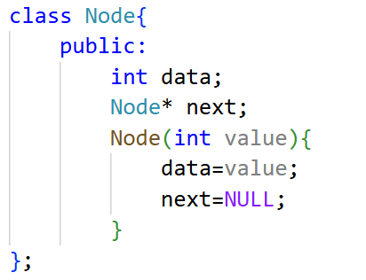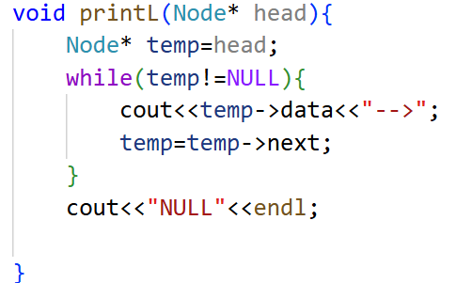

- Write a function to insert a new node at the beginning.

CODE:
void insertAtB(Node* &head,int value){
Node* temp=new Node(value);
temp->next=head;
head=temp;
}

int main(){
Node* head=new Node(1);
Node* second=new Node(2);
Node* third=new Node(3);
Node* fourth=new Node(4);
head->next=second;
second->next=third;
third->next=fourth;

printL(head);
insertAtB(head,5);
printL(head);
}

Output
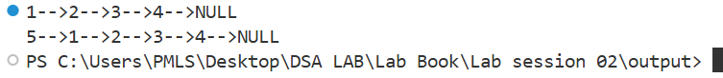

- Write a function to delete the last node in the list:

CODE:
void popL(Node* head){
Node* temp=head;
while(temp->next->next!=NULL){
temp=temp->next;
}
temp->next=NULL;
}

int main(){
Node* head=new Node(1);
Node* second=new Node(2);
Node* third=new Node(3);
Node* fourth=new Node(4);
head->next=second;
second->next=third;
third->next=fourth;

printL(head);
popL(head);
printL(head);
}

Output
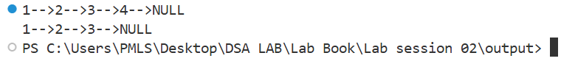

- Count the total number of nodes in the linked list:

CODE:
int main(){
Node* head=new Node(1);
Node* second=new Node(2);
Node* third=new Node(3);
Node* fourth=new Node(4);
Node* fifth=new Node(5);
head->next=second;
second->next=third;
third->next=fourth;
fourth->next=fifth;

printL(head);

int count=0;
Node* temp=head;
while(temp!=NULL){
count++;
temp=temp->next;
}

cout<<"Total Number of Nodes are: "<<count;
}

OUTPUT:
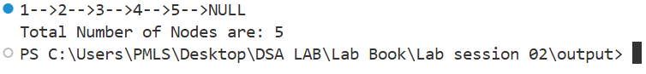

- Write a function to search for a value in the linked list.
CODE:
bool searchV(Node* head,int value){
Node* temp=head;
while(temp!=NULL){
if(temp->data==value){
return true;
}
temp=temp->next;
}
return false;

}

int main(){
Node* head=new Node(1);
Node* second=new Node(2);
Node* third=new Node(3);
Node* fourth=new Node(4);
Node* fifth=new Node(5);
head->next=second;
second->next=third;
third->next=fourth;
fourth->next=fifth;

printL(head);
bool search=searchV(head,5);

if(search){
cout<<"Value Found!!!!";
}
else{
cout<<"Value Not Found!!!";
}
}

OUTPUT:
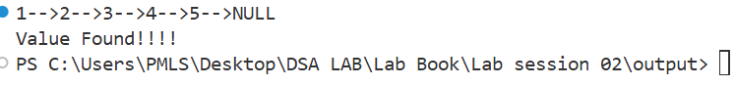
- Write a function to reverse the linked list iteratively.

CODE:
Node* reverseL(Node* head){
Node* prev = NULL;
Node* current = head;
Node* next = NULL;

while(current != NULL){
next = current->next;
current->next = prev;
prev = current;
current = next;
}
return prev;
}

int main(){
Node* head=new Node(1);
Node* second=new Node(2);
Node* third=new Node(3);
Node* fourth=new Node(4);
Node* fifth=new Node(5);
head->next=second;
second->next=third;
third->next=fourth;
fourth->next=fifth;

printL(head);
head = reverseL(head);
printL(head);
}

OUTPUT:
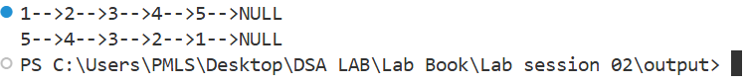

- Write a function to sort the linked list in ascending order:
CODE:
void bubbleSort(vector<int>& arr, int n) {
for (int i = n - 1; i > 0; i--) {
for (int j = 0; j < i; j++) {
if (arr[j] > arr[j + 1]) {
swap(arr[j], arr[j + 1]);
}
}
}
}

void sortL(Node* head) {
if (head == NULL || head->next == NULL) return;

vector<int> arr;
Node* temp = head;

while (temp != NULL) {
arr.push_back(temp->data);
temp = temp->next;
}

bubbleSort(arr, arr.size());

temp = head;
int i = 0;
while (temp != NULL) {
temp->data = arr[i++];
temp = temp->next;
}
}

int main(){
Node* head=new Node(1);
Node* second=new Node(4);
Node* third=new Node(2);
Node* fourth=new Node(3);
head->next=second;
second->next=third;
third->next=fourth;

printL(head);
sortL(head);
printL(head);
}

OUTPUT:
